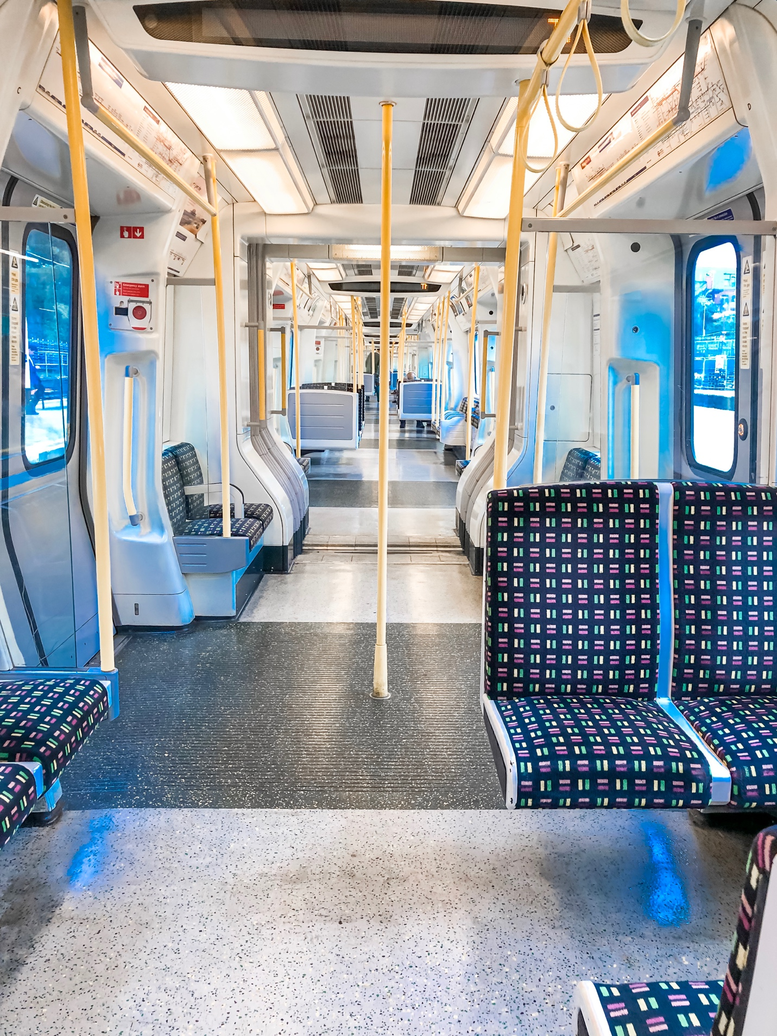

**1. Don't hop onto the train and just stop.**

It's always a rush to get onto the train, but when I do finally enter the train, I try to keep moving into the aisles (or at very least just keep moving into the area just beyond the door) so I don't block the door. I know there are people behind me, also trying to get on the train. And if you have a short journey (aka shorter than two stops), its okay to stay in the general vicinity of the doors, but if its THAT crowded, people will understand and move out of the way for you to exit from the middle of the carriage. They'll just be glad they had room to get on the train.

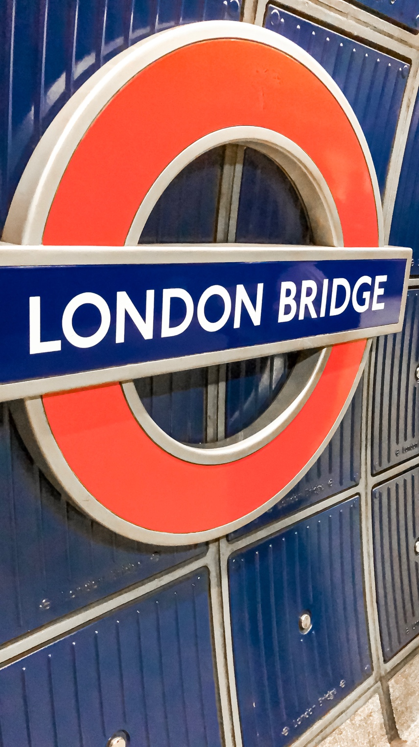

**2. Keep your card handy.**

The barriers sneak up on me all the time, but I keep my card handy so I don't have to be that person that slow walks RIGHT in front of the gates, getting in everyone's way, while rummaging around in my purse or pocket trying to dig out my card. I know I use it getting on and off the train so I like to keep it handy, especially on short train trips. If I'm on longer trips, especially trips that I have to change a bunch on, I will put my card away (because I'm not TRYING to lose it), but I make sure to take it back out at a convenient place (aka at my seat before I arrive at my destination station). NOT right in front of the gates...I really can't stress that enough.

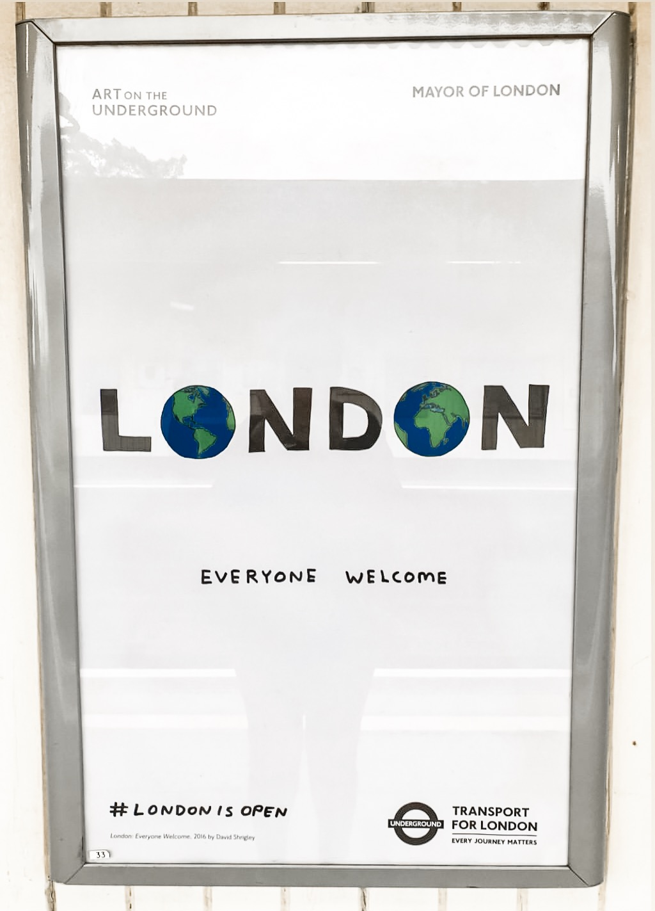

**3. Don't block the middle of the platform.**

I am not sure if it's just the culture in London or just me but people seem to just stop or take up the entire walkway without a care or concern for others trying to hustle along to the next train or to the exit. I'm not trying to be the person in EVERYONE'S way and I make sure to move to one side if I would like to walk leisurely (basically all the time unless I'm commuting to or from work) or, especially, if I'm stopping. Basically, just be considerate.

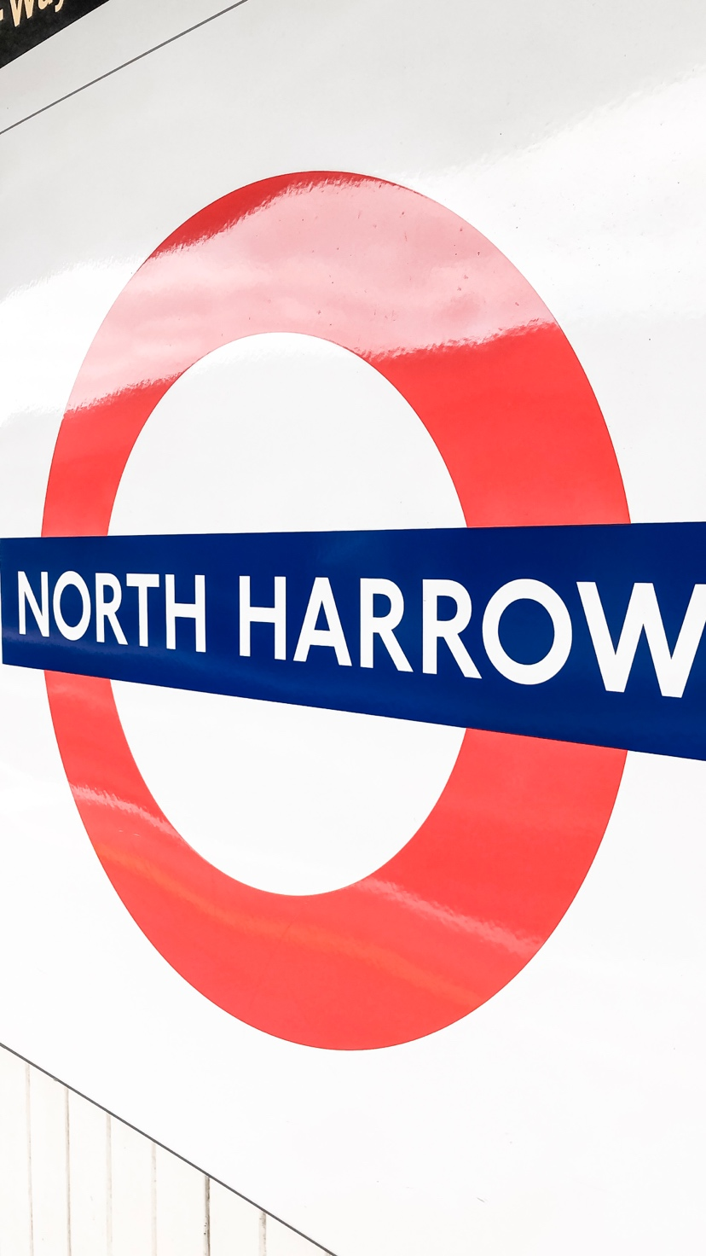

**4. Don't man-spred...or woman-spred.**

It's not just airplanes, guys. You can't man-spread (or lean over the arm rest, or really just be in someone else's space at all) on trains too. Women are usually very aware of how much space they take up (thanks for that society) and are usually not the culprits of this (although it still happens WAY too often). Men, however, we gotta chat. I paid my fare just like you did and don't appreciate having to avoid your hairy, sweaty extremities when they're encroaching on MY space. Boy bye.

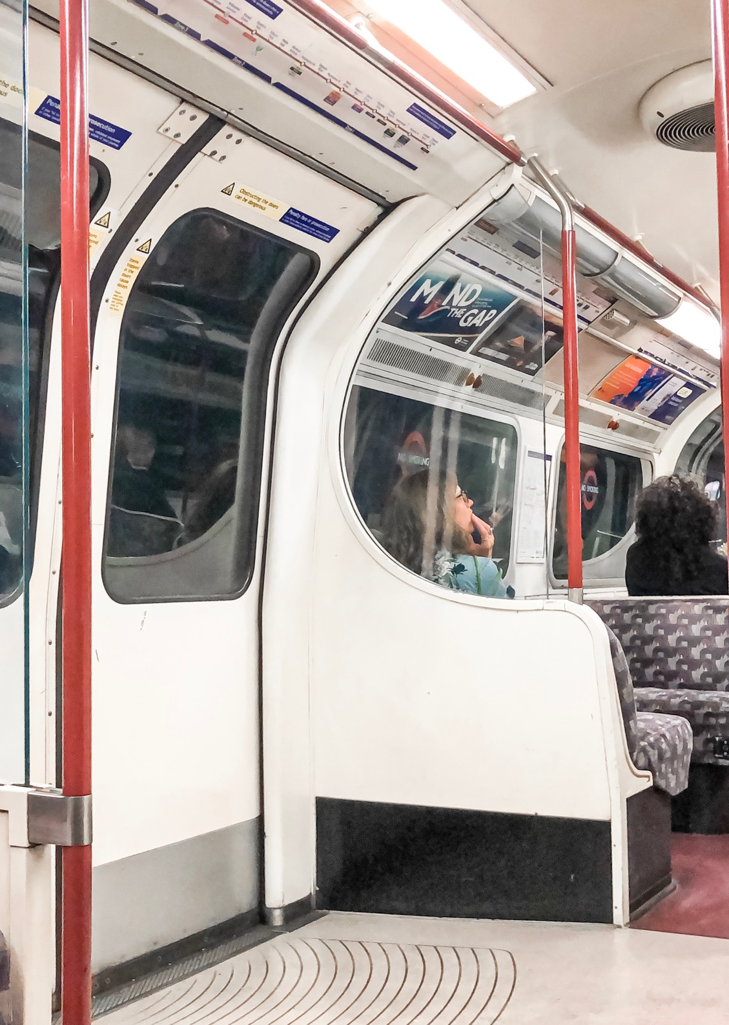

**5. Don't block the gate.**

I've already covered this general concept, but I feel the need to address this directly. If your card doesn't work, first, move to the side, then, and only then, pick a different card or talk to the TFL staff there to help you. Like I said, REALLY can't stress this one enough.

Leave me a comment below with your tube etiquette tips. What would you add to (or emphasize in) this list? For more, make sure to follow [@JustPlaneCarly](http://instagram.com/justplanecarly)and [@StaffTraveler](http://instagram.com/stafftraveler)on Instagram.